**EIS Technical Memo EIS-XX-XXX**

**To: EIS Project**

**From: Peter Santana Rodriguez**

**Subject: Accurate edge coordinates for framing area and filter stripes**

**Version: 1.0**

**Date: Aug 1, 2022**

# Summary

As a need for getting accurate coordinates of edges in the WAC focal plane, analysis and signal profiles were captured from flat field Panchromatic low gain images. These images were dark and bias corrected, and the maximum pixel value was taken for each image stack to create a map image of the focal plane. The focal plane map (Flat_Field_Pan_Low_Gain_Max.fit) has dimensions of 2048 rows x 4096 columns. Using python, we were able to get the signal profiles for each of the edges and utilizing the FWHM and visual inspection, we identified the coordinates for these edges.

Accurate width measurements for the colored stripes were compiled by utilizing a similar technique with the FFC and FFC_1MC data sets. With this, we found that generally the stripes consisted of 32 rows of width while also cataloguing the reduced response along the mask edges as observed with the flat field panchromatic data.

The following datasets were used for this analysis:

<https://eis-gway.jhuapl.edu/fits_browser?dir=/project/europaeis/data/prelaunch/WAC_FM/20220509_calibration/20220524_174122_FLAT_FIELD_PAN_LOW_GAIN>

<https://eis-gway.jhuapl.edu/fits_browser?dir=/project/europaeis/data/prelaunch/WAC_FM/20220509_calibration/20220524_225220_FLAT_FIELD_COLOR>

<https://eis-gway.jhuapl.edu/fits_browser?dir=/project/europaeis/data/prelaunch/WAC_FM/20220509_calibration/20220526_003609_FLAT_FIELD_COLOR_1MC>

<https://eis-gway.jhuapl.edu/fits_browser?dir=/project/europaeis/data/prelaunch/WAC_FM/20220509_calibration/20220526_014239_FLAT_FIELD_COLOR_NUV>

2 Edge Coordinates

The panchromatic mask edges are provided below, including both the framing area and the clear stripe.

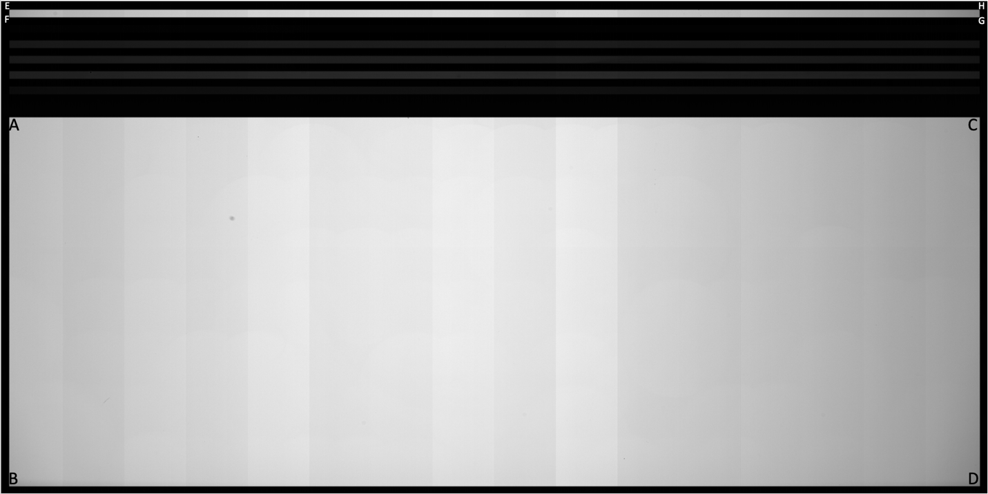

|  |  |
| --- | --- |
| Letter | Edge Coordinate (x,y) Via FWHM |
| A (Upper Left Framing Area Edge) | (35, 1564) |
| B (Bottom Left Outer Edge / Framing Area Edge) | (35, 29) |
| C (Upper Right Framing Area Edge) | (4064, 1564) |
| D (Bottom Right Outer Edge / Framing Area Edge) | (4065, 30) |
| E (Upper Left Outer Edge / Clear Filter Edge) | (36, 2011) |
| F (Lower Left Clear Filter Edge) | (36, 1980) |
| G (Lower Right Clear Filter Edge) | (4063, 1980) |
| H (Upper Right Outer Edge / Clear Filter Edge) | (4064, 2011) |

# Profiles

For each of the edges, profiles were taken averaging out 10 rows/columns for each of the edges.

## 3.1 Outer Edges

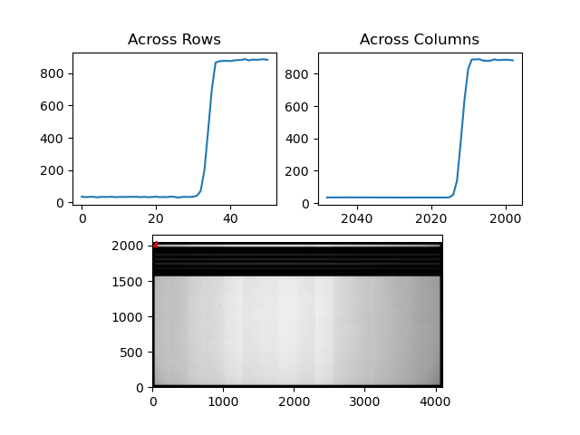

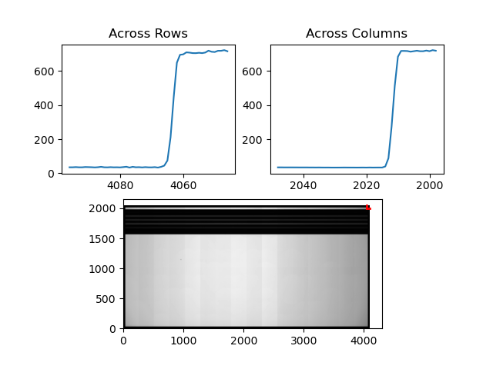

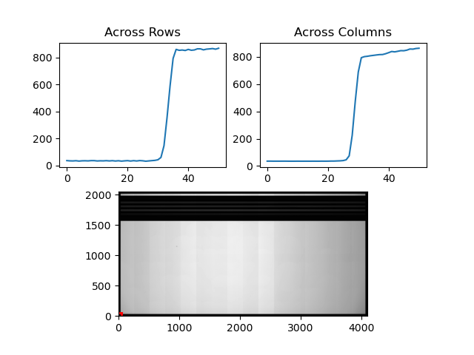

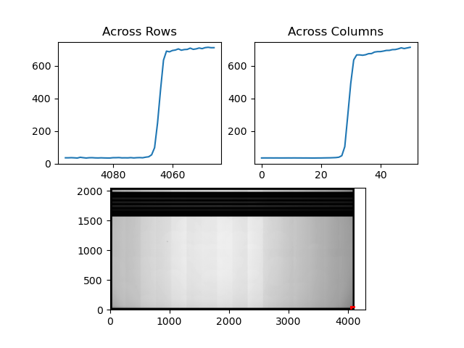

3.2 Framing Area Edges

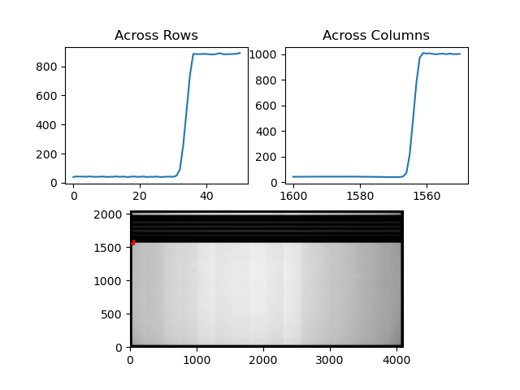

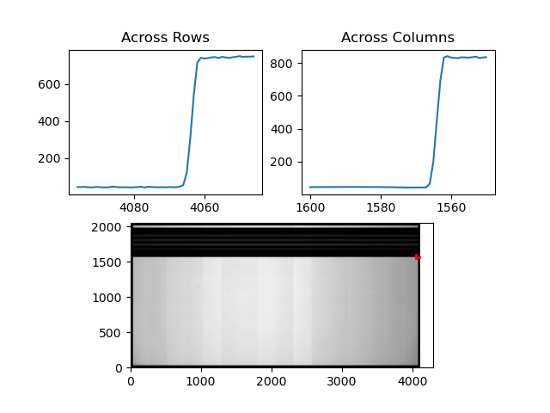

3.3 Clear Filter Edges

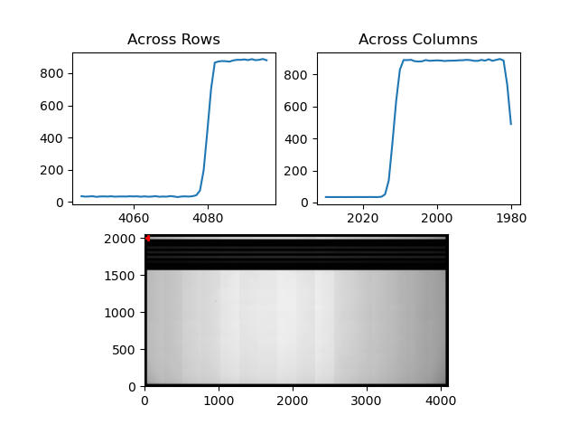

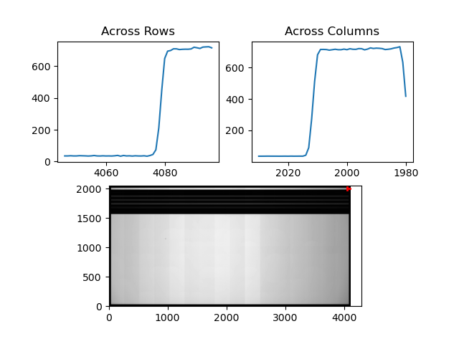

# Profiles for colored Stripes

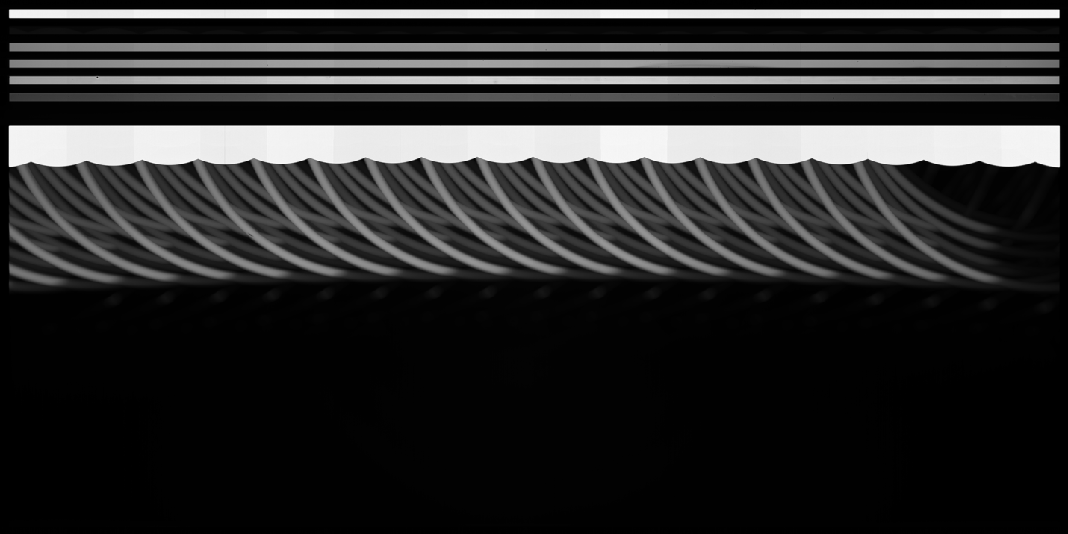

Using this flat field color map (FlatFieldColorMax.fit) and FlatFieldColorMax1MC.fit), we were able to obtain the different profiles located alongside the colored stripes. In this case, visual inspection alongside with profile measurements were compiled to get approximate corner coordinates for each of the stripes. After that, we measured row profiles alongside 3 column positions (x) being 86, 2111, and 4014. This way, we could ensure if there was any rotation present alongside the edges of the stripes. For each stripe, we provide the edge estimate using the FWHM (includes transition region), the fully dark mask positions, and the full response illuminated edges. The ultraviolet filter (NUV) is excluded from this analysis due to the difficulty in obtaining sufficient signal in the stripe without light leakage into the opaque stripes.

**One Micron Filter Stripe (1MC)**

|  |  |
| --- | --- |
| Approximate Corner Half Max Coordinates | Location |
| (35, 1917) | Lower Left Corner |
| (35, 1947) | Upper Left Corner |
| (4064, 1916) | Lower Right Corner |
| (4064, 1947) | Upper Right Corner |

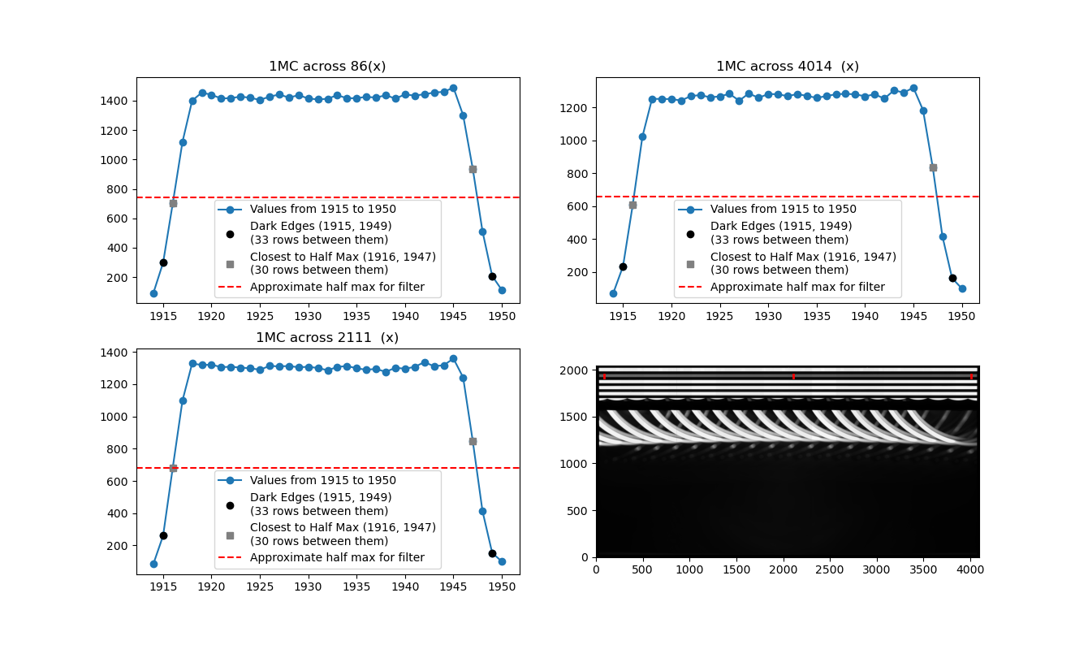

Profile measurements for rows in the stripes were taken alongside three column positions to determine where the edge was located. For the 1MC filter stripe, we have that the bounding opaque stripes are fully dark at **row 1915** and **row 1949**, which bookends 33 rows. For the half max values, the closest rows to the FWHM value only had 30 rows between them being located alongside **row 1916** and **row 1947**. The 1MC stripe exhibits essentially flat response from row 1918 to row 1945, a total of 29 rows.

The values from the 1MC profiles are reported below:

Across column 86(x):

[ 93. 298. 702.5 1119. 1400.5 1455. 1440. 1415. 1417.5 1427.5

1420. 1405. 1427.5 1442. 1421. 1437.5 1415. 1408.5 1413. 1438.

1416. 1417.5 1426. 1421. 1437. 1414.5 1442.5 1434.5 1444. 1455.

1460.5 1488.5 1301. 935. 512. 208. 112.5]

Across column 2111(x):

[ 86. 260. 683. 1098. 1328.5 1319. 1321. 1306. 1308. 1303.

1299. 1289.5 1313.5 1310.5 1313. 1305. 1308. 1300.5 1286.5 1307.

1313. 1298.5 1289.5 1295. 1276.5 1302. 1296. 1307.5 1337. 1311.

1318. 1359. 1242. 845. 413. 154. 100.]

Across column 4014(x):

[ 72. 234. 607. 1022. 1253.5 1252. 1252. 1242.5 1270. 1276.

1262. 1268. 1283.5 1242. 1286. 1259. 1282.5 1281. 1269.5 1282.

1271. 1259. 1269.5 1281. 1283.5 1280.5 1268.5 1280.5 1254.5 1305.

1291. 1321. 1184. 836.5 417. 161.5 99.]

**Blue Filter Stripe (BLU)**

|  |  |
| --- | --- |
| Approximate Corner Half Max Coordinates | Location |
| (36, 1661) | Lower Left Corner |
| (36, 1691) | Upper Left Corner |
| (4064, 1661) | Lower Right Corner |
| (4064, 1691) | Upper Right Corner |

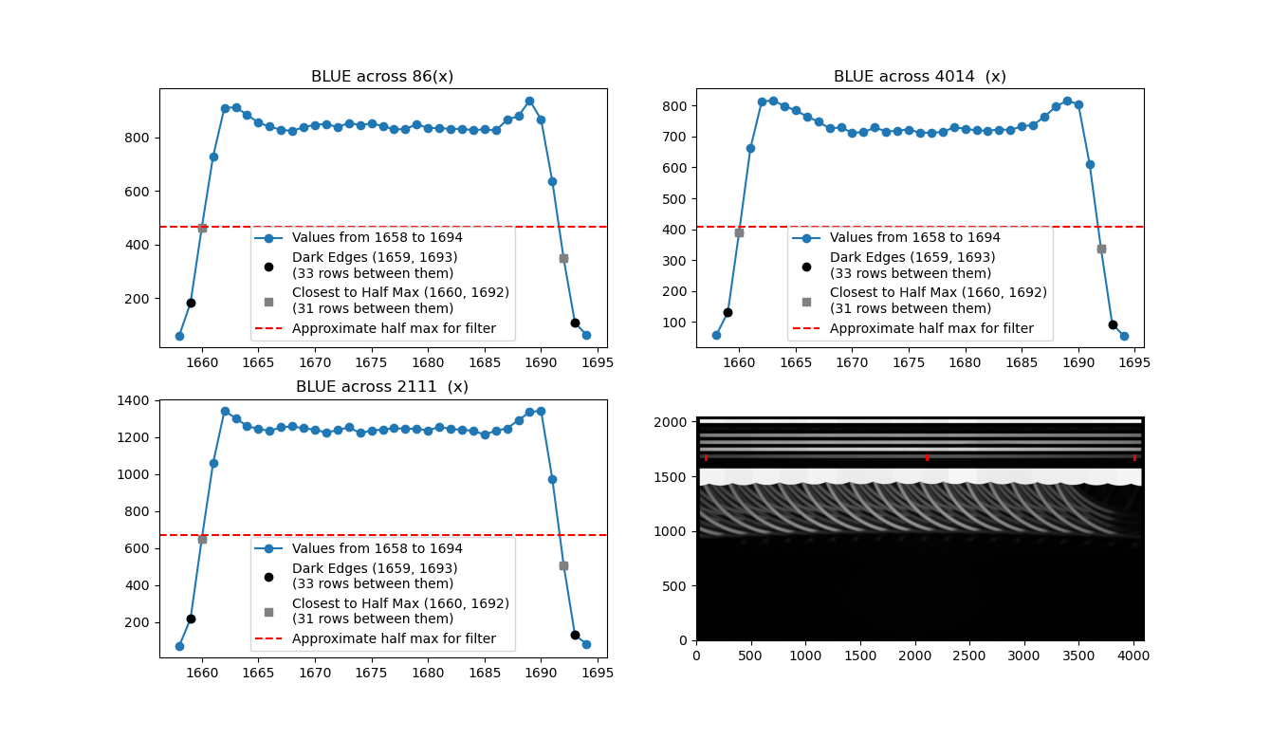

For the BLU filter stripe, we have that the bounding opaque stripes are fully dark at **row 1659** and **row 1693**, encompassing 33 filter rows. For the half max values, the closest rows to the FWHM value encompassed 31 rows from **row 1660** and **row 1692**. The BLU filter response is largely flat from row 1662 to row 1689, encompassing 29 rows in total.

The values from the BLU profiles are reported below:

Across column 86(x):

[ 61. 183. 464.5 729. 909.5 910.5 883.5 854. 839. 827.5 822.5 837.5

845.5 849. 837. 852.5 845. 850.5 841. 829. 829.5 848. 834. 833.5

830.5 830.5 826. 828.5 825. 864. 878.5 936.5 866. 635. 348. 108.5

64.]

Across column 2111(x):

[ 72. 219. 653. 1062. 1342.5 1303.5 1260. 1245.5 1234.5 1254.

1259. 1248.5 1241. 1225.5 1238.5 1254. 1223. 1236. 1242. 1248.5

1246.5 1246. 1237. 1256. 1244.5 1241. 1235. 1214.5 1235.5 1248.

1292.5 1337. 1343. 975. 509.5 131. 84.]

Across column 4014(x):

[ 59. 131. 390.5 662. 813. 816.5 798.5 784. 765. 748. 726. 729.

712.5 713.5 729. 716. 718.5 722.5 712. 712.5 714. 729.5 725. 719.5

718.5 722.5 721. 733. 737. 763.5 796.5 815.5 804.5 610.5 338.5 93.5

56.]

**Green Filter Stripe (GRN)**

|  |  |
| --- | --- |
| Approximate Corner Half Max Coordinates | Location |
| (36, 1725) | Lower Left Corner |
| (36, 1755) | Upper Left Corner |
| (4064, 1725) | Lower Right Corner |
| (4063, 1755) | Upper Right Corner |

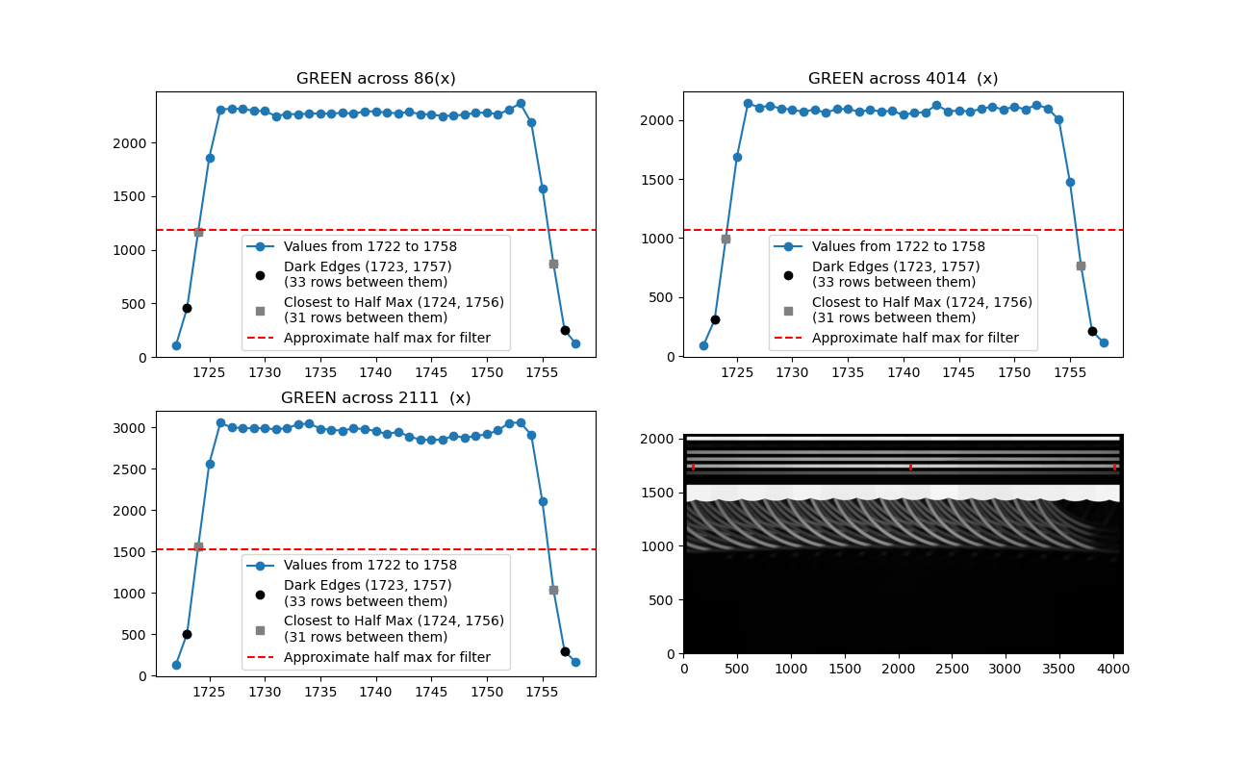

For the GRN filter stripe, we have that the bounding opaque stripes are fully dark at **row 1723** and **row 1757**, which encompasses 33 filter rows. For the half max values, the closest rows to the FWHM value encompassed 31 rows between **row 1724** and **row 1756**. The GRN filter response is largely flat from row 1726 to row 1754, encompassing 29 rows in total.

The values from the GRN profiles are reported below:

Across column 86(x):

[ 111. 456. 1170. 1861. 2307.5 2316.5 2314.5 2296. 2293.5 2247.

2266. 2263.5 2270.5 2272. 2268. 2279.5 2267.5 2292. 2290. 2279.5

2272.5 2286. 2265.5 2262. 2247.5 2251.5 2260. 2276.5 2280.5 2263.5

2305.5 2366. 2186. 1575. 870.5 253. 125.]

Across column 2111(x):

[ 134. 505. 1555. 2566.5 3057.5 2999. 2995.5 2989.5 2994. 2976.

2994. 3037.5 3048.5 2987. 2971. 2963. 2991.5 2980.5 2958. 2920.

2949. 2893. 2854. 2850.5 2853.5 2900. 2877.5 2898. 2918.5 2964.5

3055.5 3061. 2913.5 2104.5 1039. 294. 162.]

Across column 4014(x):

[ 94. 309. 992. 1684. 2141. 2107. 2121. 2095. 2088.5 2068.

2090. 2060.5 2093. 2092.5 2070.5 2083. 2073.5 2075.5 2043.5 2060.

2066.5 2127. 2074. 2079. 2072. 2092.5 2114.5 2087. 2113.5 2089.

2128.5 2099. 2002.5 1475. 768. 212. 118.]

**Red Filter Stripe (RED)**

|  |  |
| --- | --- |
| Approximate Corner Half Max Coordinates | Location |
| (36, 1789) | Lower Left Corner |
| (36, 1819) | Upper Left Corner |
| (4063,1789) | Lower Right Corner |
| (4063, 1819) | Upper Right Corner |

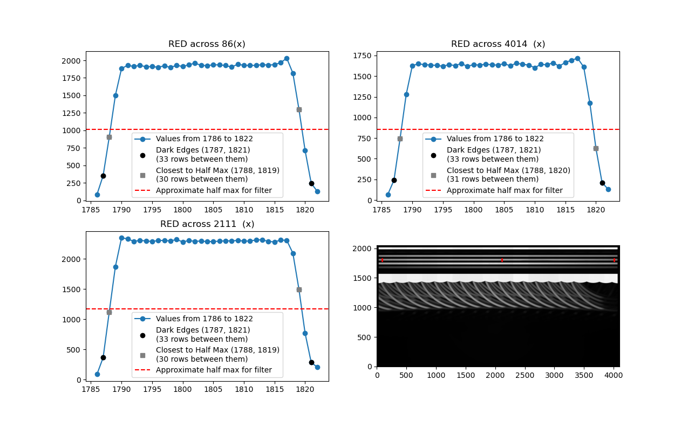

For the RED filter, we have that the bounding opaque stripes are fully dark at **row 1787** and **row 1821**, meaning the filter is 33 rows. For the half max values, the closest rows to the FWHM value encompassed 30 rows between **row 1788** and **row 1819**. Except in the right edge, where we noticed a shift in the rows where the half max is on row 1820. The RED filter response is largely flat from row 1790 to row 1817, encompassing 29 rows in total.

The values from the RED profiles are reported below:

Across column 86(x):

[ 85.5 353. 906. 1499.5 1882. 1930.5 1912. 1929. 1909. 1911.5

1901.5 1923. 1899. 1929. 1912.5 1937. 1960.5 1929. 1925.5 1937.

1935.5 1927. 1904. 1946.5 1927.5 1929. 1927. 1940.5 1931.5 1940.

1966.5 2031.5 1818. 1297.5 712. 243. 127.5]

Across column 2111(x):

[ 90. 364. 1123. 1873. 2349. 2335.5 2291. 2308.5 2299.5 2290.5

2305.5 2308.5 2299. 2323.5 2283.5 2305. 2293. 2297.5 2288. 2290.5

2294.5 2301.5 2299. 2309. 2296. 2297.5 2316. 2318.5 2291. 2283.

2313.5 2309.5 2097. 1491.5 768. 282.5 205.]

Across column 4014(x):

[ 68.5 240. 746. 1279. 1627. 1649. 1638.5 1635. 1630. 1619.

1640. 1627.5 1653.5 1617. 1641.5 1631.5 1647.5 1635.5 1634.5 1651.

1625. 1657.5 1642. 1635. 1602. 1643. 1637. 1661. 1621. 1665.5

1692.5 1717.5 1611. 1177. 626. 211. 130.]

**Infrared Filter Stripe (IR1)**

|  |  |
| --- | --- |
| Approximate Corner Half Max Coordinates | Location |
| (36, 1853) | Lower Left Corner |
| (36, 1883) | Upper Left Corner |
| (4063,1853) | Lower Right Corner |
| (4063, 1883) | Upper Right Corner |

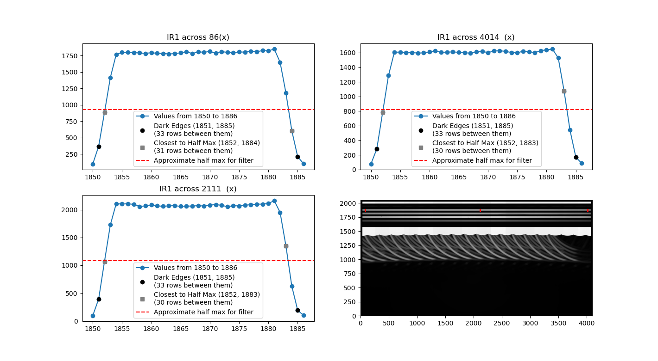

For the IR1 filter stripe, we have that the bounding opaque stripes are fully dark at **row 1851** and **row 1885**, encompassing 33 rows. For the half max values, the closest rows to the FWHM value encompassed 30 rows between **row 1852** and **row 1883**, with the exception of a shift on the left edge where the half max goes to row 1884. The IR1 filter response is largely flat from row 1854 to row 1881, encompassing 28 rows in total.

The values from the IR1 profiles are reported below:

Across column 86(x):

[ 97.5 366.5 883.5 1415.5 1768. 1798.5 1800.5 1795. 1791.5 1784.

1794.5 1785. 1783. 1776. 1780. 1793. 1808.5 1782. 1807. 1802.

1812.5 1787.5 1812. 1799. 1796. 1806. 1803. 1818. 1809.5 1826.5

1823.5 1850. 1649. 1179. 605. 209. 101.]

Across column 2111(x):

[ 95. 391.5 1070. 1730. 2110. 2104. 2109.5 2097.5 2060. 2071.

2089. 2071. 2064. 2071. 2075. 2062. 2068. 2067. 2076.5 2068.

2086. 2094. 2082. 2056. 2075. 2070. 2083. 2093. 2102. 2103.

2114.5 2164.5 1953.5 1346.5 625. 191. 98.]

Across column 4014(x):

[ 76. 281.5 783. 1287.5 1605.5 1608.5 1597.5 1600.5 1595.5 1597.

1611. 1623.5 1604.5 1608. 1610. 1605.5 1598.5 1594. 1610.5 1619.5

1600. 1623.5 1626. 1618.5 1602. 1597. 1621.5 1613.5 1601. 1626.5

1640.5 1649.5 1528.5 1075. 541. 170. 84.]

# Mask Transition Region

# A visual example of reduced signal due to the presence of the mask can be observed below. This region of reduced response approaching the opaque stripes is typically 2-3 pixels.

